Necessary modification to **main.py, creditflux.py** and **main2.py**:

There is a global_folder variable in each py file, and you need to change those to the **local path** to your creditflux_downloader folder.

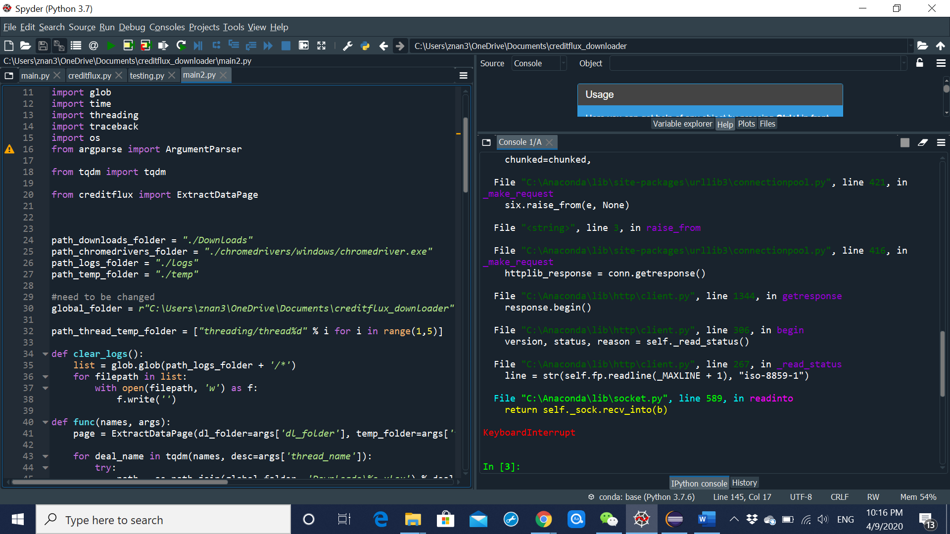

To successfully generate the executable file, after changing the path, you need to use **pyinstaller** to generate the exe file. It will take a few steps to accomplish this, but you can also directly download CLO deals from java, and the instruction is clearly stated from page 3.

In this page, I will illustrate how to construct the executable file.

You first need to install pyinstaller using **pip install pyinstaller** or **conda install pyinstaller.**

After that, under the filepath of your creditflux_downloader folder, open cmd, and type **pyinstaller --onefile main.py**

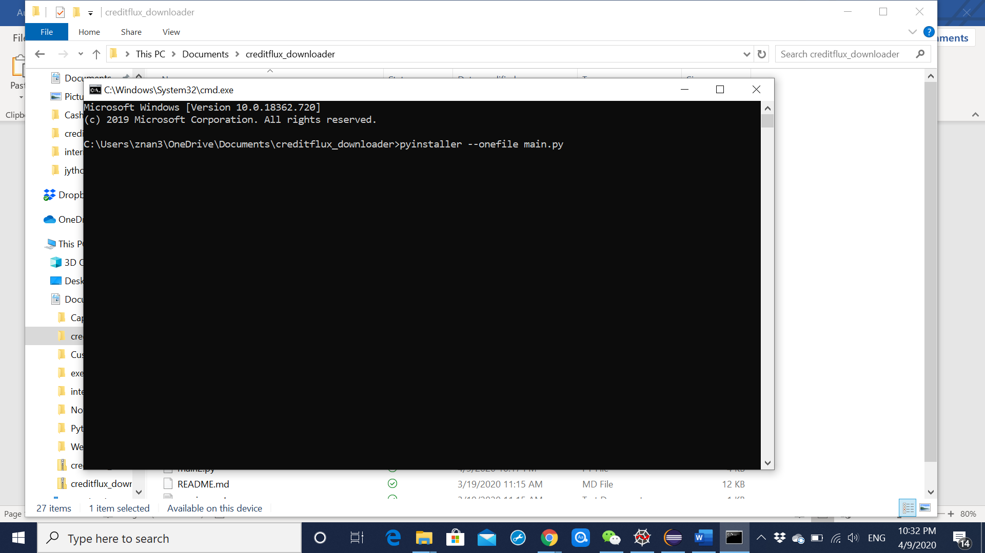

This step will generate a filecalled **main.spec**, open it and add two lines of code at the top:

**Import sys**

**sys.setrecursionlimit(5000)**

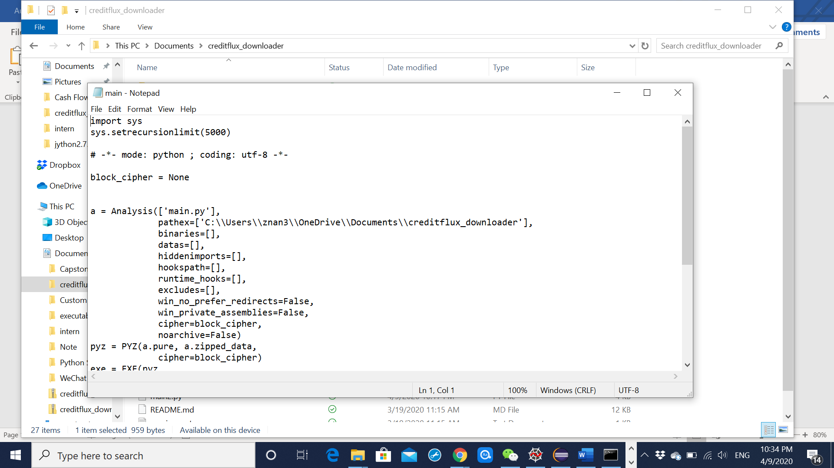

After saving the file, again under the filepath of your creditflux_downloader folder, open cmd, and type **pyinstaller --onefile main.spec**

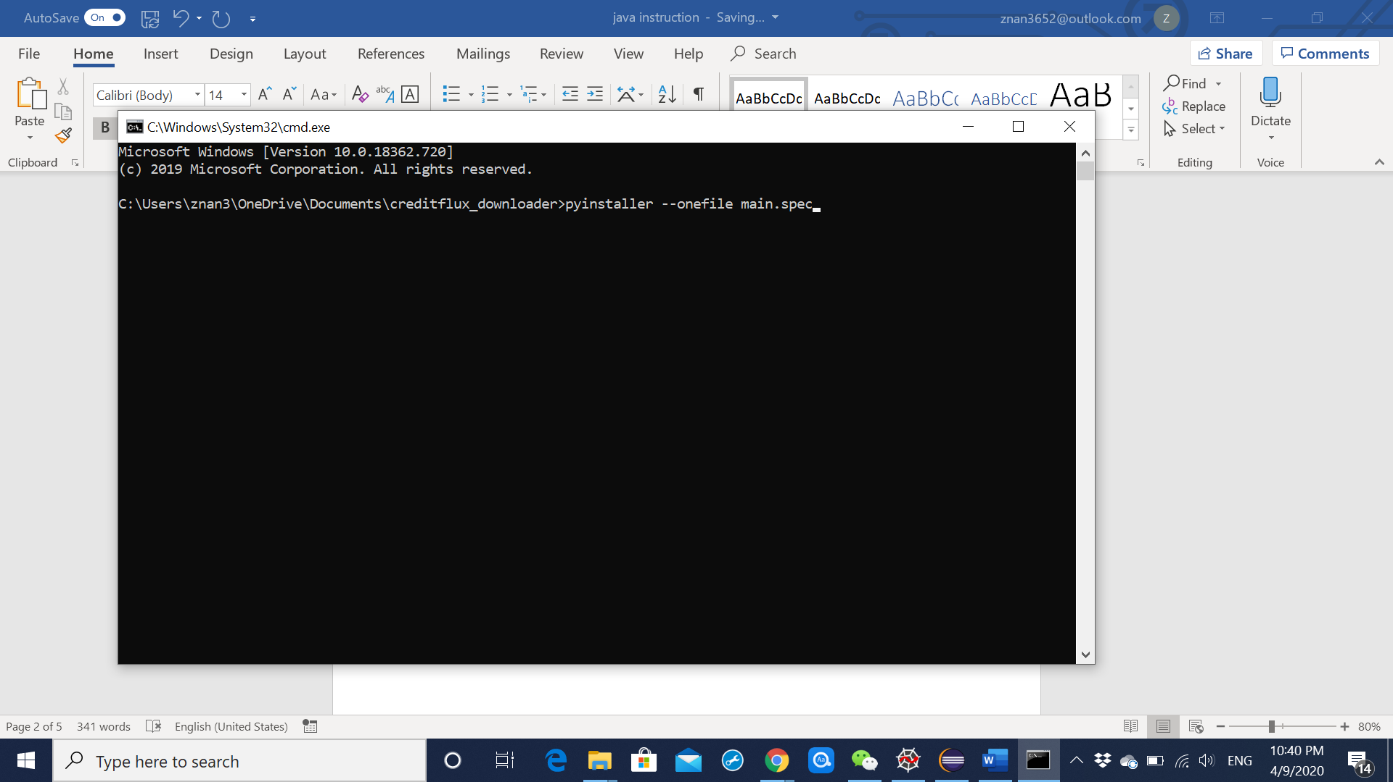

It may take a while to generate the main.exe file. The file will be generated under the dist folder, and you can drag it to the creditflux_downloader folder, which means placing it in the same location as other py files.

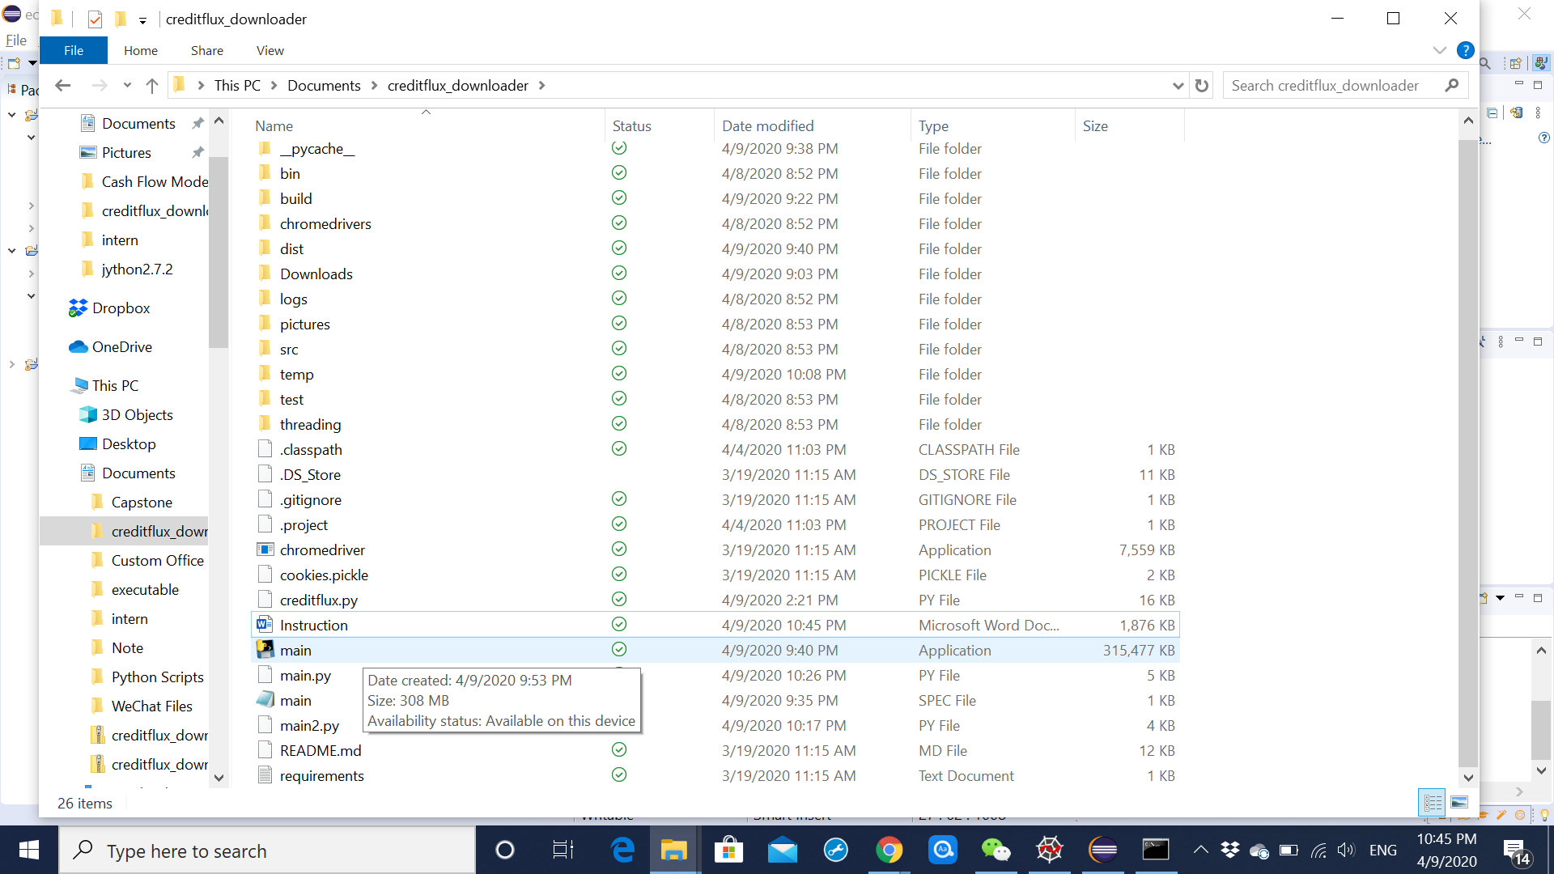

Go to the next page to see how to use java to call the main.exe and how to directly download CLO deals from java.

Java instructions:

Click Run, and the program will give you some prompts.

You can open main.exe by saying yes to the first question.

You can directly download deals by giving the name of the single deal or the filepath of the txt file containing all the deal names. It may take a while to download.